EXPERIMENT 3

AIM
To develop a flowchart in Figma depicting the operation of a Network Switching Subsystem (NSS) in a mobile cellular system.

PROCEDURE
- Open Figma and create a new design file.
- Create flowchart shapes representing the major stages of network switching.
- Start with Mobile Station (MS) initiating a call through the Base Transceiver Station (BTS).
- Connect the BTS to the Base Station Controller (BSC), which manages radio resources and forwards the call request.
- Connect the BSC to the Mobile Switching Centre (MSC), which processes the call and controls switching.
- Include the Home Location Register (HLR) and Visitor Location Register (VLR) to verify subscriber details and retrieve location information.
- Add a decision diamond to check whether the subscriber is valid. Show separate paths for valid and invalid subscribers.
- For a valid subscriber, show call routing to the destination network or another mobile station. For an invalid subscriber, show call rejection.
- Use arrows to connect the shapes, apply suitable colours, and arrange the flowchart clearly.
- Use Figma's Prototype feature to connect interactive elements and preview the completed flowchart.

FLOWCHART

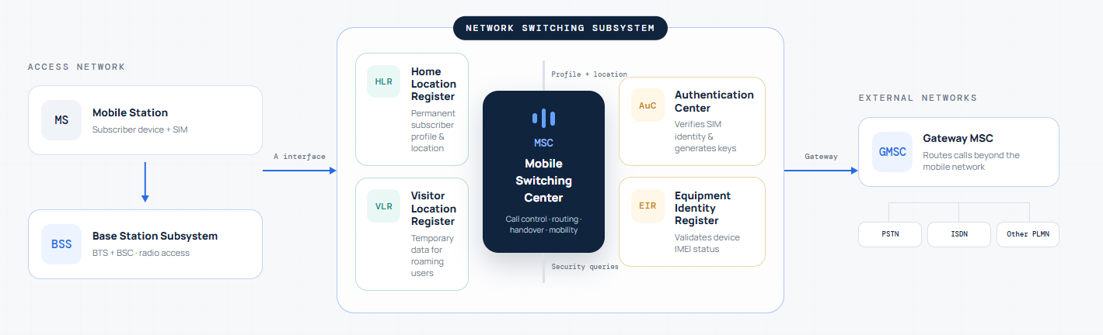

RESULT
A flowchart illustrating the operation of the Network Switching Subsystem in a mobile cellular system was developed in Figma, showing call initiation, subscriber verification, call routing, and call connection or rejection.

